**Video 1**

1. **Duration:-** If 1, then for one second the animation will run
2. **Delay:-** If 1, then after one second the animation will start
3. **Repeat:-** If 2, the animation will repeat for 2 times

If -1, the animation will repeat for infinite times

1. **Stagger:-** It is applied on more than one similar elements. If 1, then with the interval of one second the animation will run on each element
2. **Yoyo:-** If true, the animation will run in the forward(to) as well as in the backward(from) direction. It will create a bounce type effect if repeat is -1 i.e. infinite.
3. **gsap.utils.mapRange():-** It helps to get a value in a range. Search the docs for more details.
4. **Timeline:-** It is used to run more than one element in a synchronous way. It will connect all the elements and the next element will only animate when the its previous element is animated.

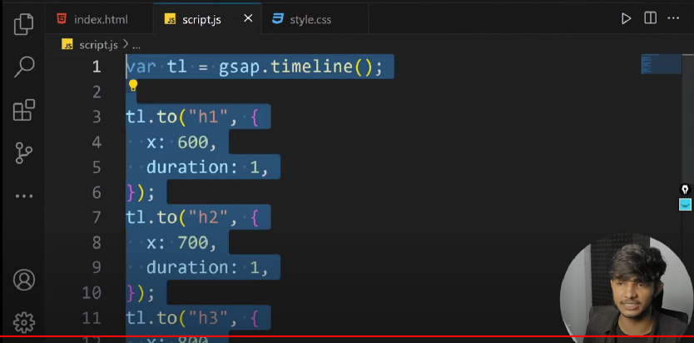

**Video 2**

Made the project 1



**Video 3**

**Scroll Trigger:**

* It is a plugin of Gsap.
* It is used to run the animations on the other page when we scroll to that page.
* To use this, cdn of this has to be added separately in script.js after the cdn of Gsap. You can find the cdns on the same page at the bottom.

1. Method 1:- We can directly target the element on the second page. Only when we scroll to the second page it will animate.

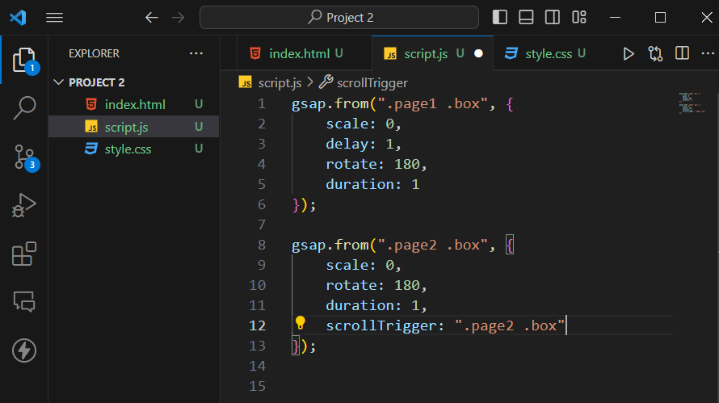

1. 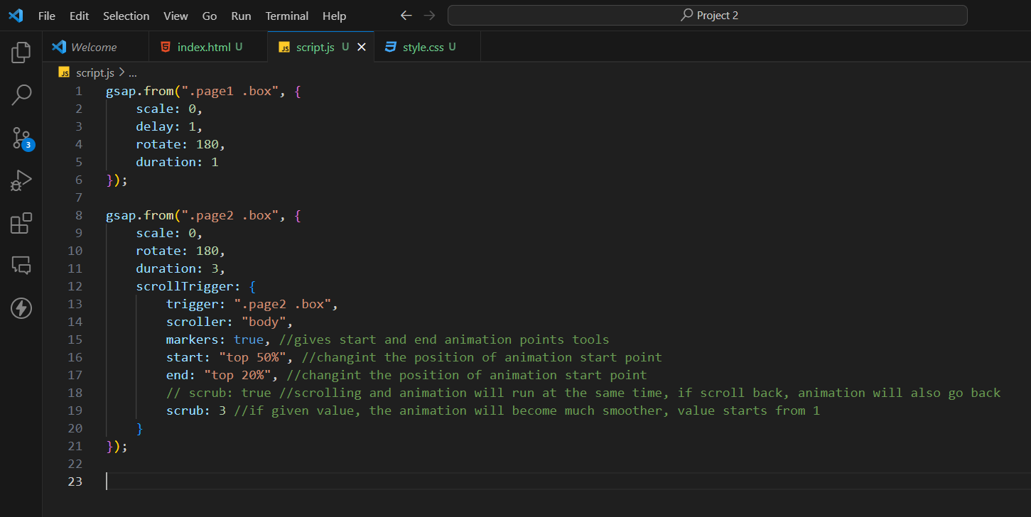Method 2(with more properties):-

**Demo:-**

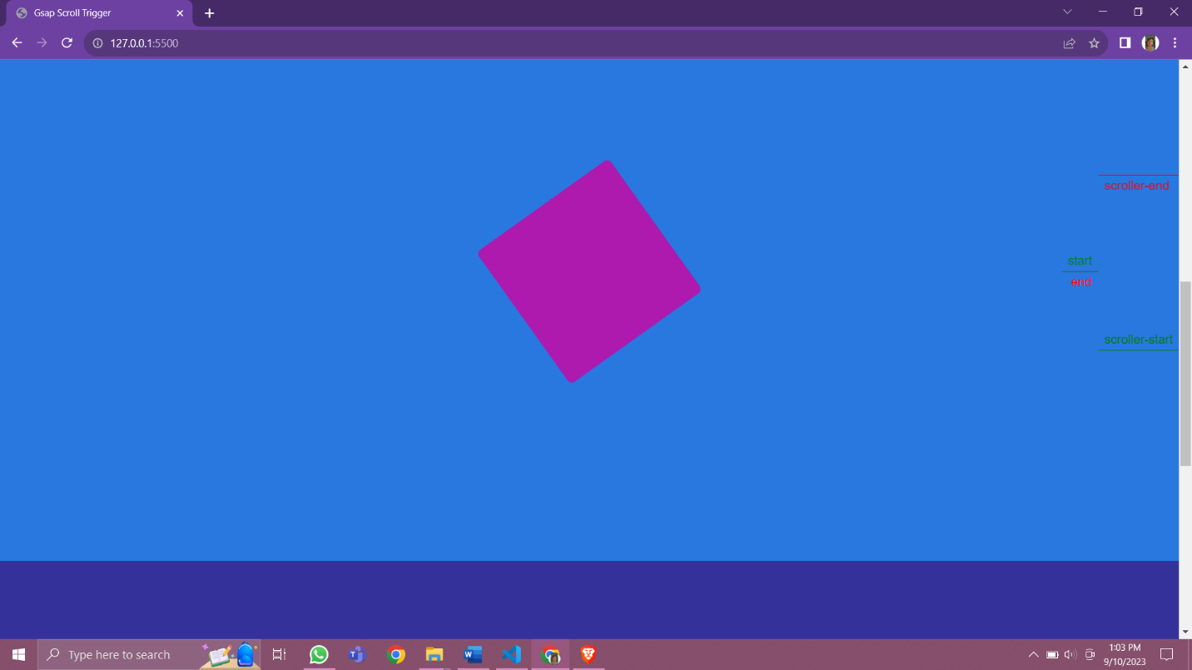

**Video 4**

Made the project 2





**Video 5**

Build Project 3 but only half





**Video 6**

Made the loader. After the loader page loads to 100% then the website comes up.

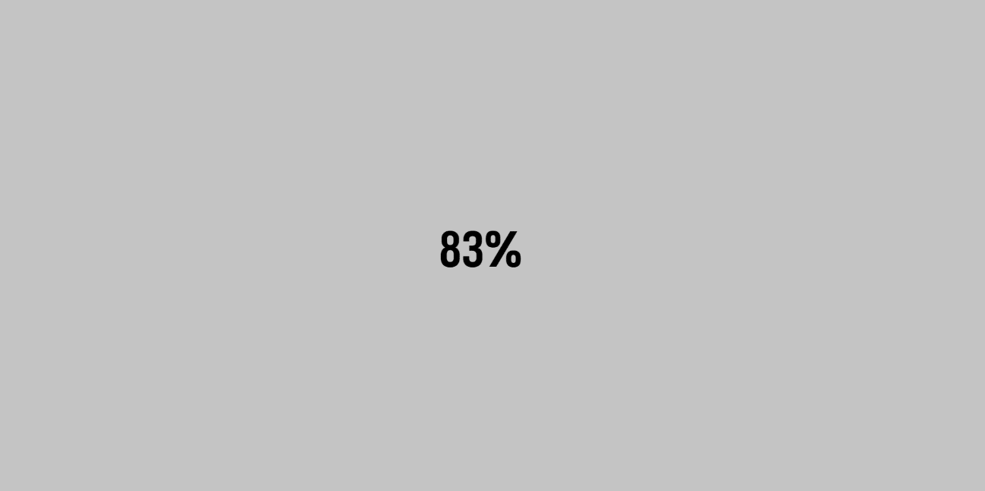

**Video 7 (Locomotive JS)**

* Learned locomotive for smooth scrolling of the page.
* If you are scrolling the main page then don’t give height to the main page. Which means the structure should be right to run locomotive.
* If position if fixed, use of scrollTrigger then it doesn’t work. (Solved this in video 8)
* It’s cdn link should always be at the top of all other cdn links.

**Video 8 (Merging Locomotive JS with GSAP)**

* Visit this website:

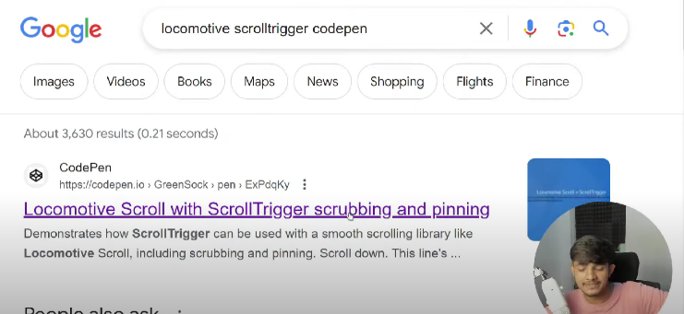

* Copy all the js code. Paste it on the top of script.js file.
* Remove the code from line 25 to 71, from RED PANNEL to other three lines below PURPPLE/GREEN PANNEL.
* Replace the word ‘’.smooth-scroll’’ with the ‘’.main’’ or whatever is the name of main container
* In the scrollTrigger, replace ‘scroller:”body”’ to ‘scroller:”.main”’ or whatever is the name of the main container